**2024 Annual Workshop Schedule**

All members or their designated representatives are required to participate in one annual outreach activity—either in-person or online (live webinar or recorded video). Annual workshops offer program updates, reporting reminders, and recommendations on best management practices. This year the annual workshop will include a presentation by U.C. Farm Advisor Dr. Mae Culumber on protective practices. Please register for webinar and in-person workshops at: <https://kingsriverwqc.org/workshops/>

|  |  |  |  |
| --- | --- | --- | --- |
| **Month / Day** | **Time** | **Location** | |
| **January** |  |
| **11** | 2:00 PM | Webinar | Zoom |
| **18** | 9:00 AM | Hanford | Kings Fairgrounds |
| **23** | 9:00 AM | Selma | Portuguese Hall |
| **30** | 9:00 AM | Webinar | Zoom |
| **February** |  |  |  |
| **6** | 9:00 AM | Easton | CPDES Hall |
| **15** | 9:00 AM | Kerman | Community Center |
| **March 1 –October 31** | Anytime | Member Portal | http://kingsriverwqc.org/account |

**Reminder: Irrigation and Nitrogen Management Plan (INMP) Summary Report Deadline - March 1, 2024**

The March 1, 2024, deadline for submitting the INMP Summary Report is fast approaching. The Central Valley Regional Water Quality Control Board (CVRWQCB) may assess fines up to $1,000 per day for non-submittals. Additionally, the CVRWQCB has begun selecting members not in compliance for on-farm inspections. All submittals must be done online through the KRWQC member portal at kingsriverwqc.org/account. The Coalition is available for assistance at [info@kingsriverwqc.org](mailto:info@kingsriverwqc.org) or 559-365-7958. Please be aware that response times increase substantially closer to March 1.

**Drinking Water Wells Must Be Sampled Annually For Nitrate Levels**

Beginning January 1, 2020, Coalition members were required to monitor for nitrates in their drinking water supply wells on enrolled parcels. The purpose of this monitoring is to identify drinking water wells that have nitrate concentrations exceeding the safe drinking water standard of 10 milligrams per liter (mg/L) as nitrogen (N). Levels of nitrate above the standard for drinking water are dangerous for one’s health, especially for infants, pregnant and nursing woman. Sampling must be completed annually unless:

* Nitrate results are less than 8 mg/L for three consecutive years. If this is the case, sampling is required every 5 years after the 3rd year of sampling. If you sampled annually from 2020 – 2022, you have reached your three consecutive years.
* Nitrate results are above 10 mg/L, the member does not need to continue to sample. Water users must be notified within 10 days with a signed copy of the notification sent to the Central Valley Regional Water Quality Board.
* The member has well nitrate results from the last 5 years from an Environmental Laboratory Accreditation Program certified laboratory.

Members that do not use their well to provide drinking water or provide bottled water are not required to monitor for nitrate but must keep records (e.g., photos/bottled water receipts) as verification.

Members must continue to sample drinking water wells annually if the nitrate result is equal to or greater than 8 mg/l and is less than or equal to 10 mg/L (>= 8 and <= 10 mg/l). Members with a filter or treatment system must sample their drinking water after the filter to determine if treatment specifications are being met.

**Irrigated Lands Regulatory Program Stakeholder meeting**

The next virtual ILRP Stakeholder meeting is scheduled for January 31, 2024, from 10 AM – 12 PM. Tentative agenda items include development of acceptable ranges for multi-year Nitrogen Applied (A) / Nitrogen Removed (R) ratio target values by crop and efforts to link management practice data to AR outcomes. More information can be found here: <http://tinyurl.com/ae7b5fa8>

**Groundwater Trend Monitoring Update**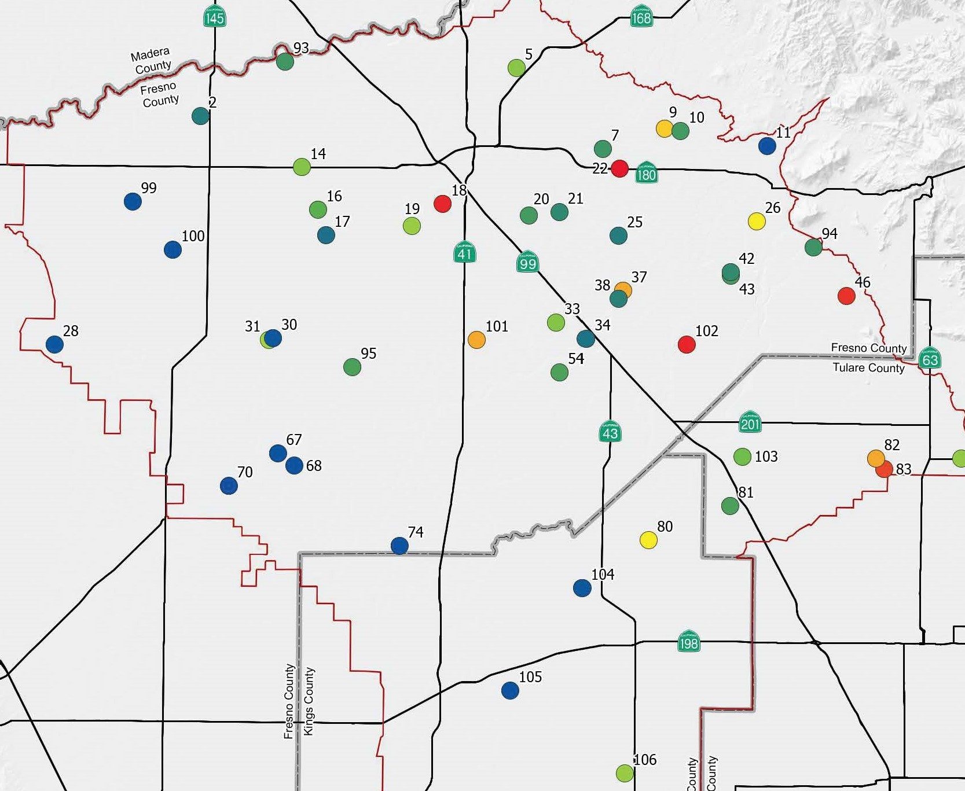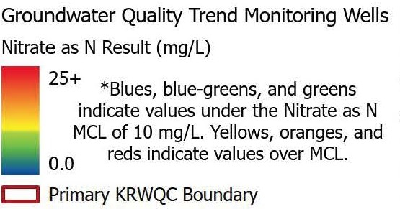Earlier in 2023, the KRWQC submitted a Groundwater Trend Monitoring Annual Status Report (Annual Report) as required by Waste Discharge Requirements General Order for Growers in the Tulare Lake Basin that are Members of a Third-Party Group, Order No. R5-2013-0120-09 (General Order). During summer of 2022, the KRWQC collected groundwater quality samples from 47 wells (19 domestic, 24 agricultural, 1 domestic\agricultural, and 3 public). Concentrations of Nitrate as nitrogen (NO3-N) above the safe drinking water limit occurred in 11 of the wells sampled (Figure 1), 5 of which were domestic wells. Of the 48 wells included in the 2022 well network, 30 wells had the minimum five data points to conduct a time series linear trend analysis. Table 1 shows linear model results for 2022 trend monitoring wells. Sampling for the 2023 well network was completed in August 2023. Additional trend analysis will be available in the 2023 Annual Report, as part of KWQC’s ongoing tracking.

**How We Arrived Here:**

On September 19, 2013, the Central Valley Regional Water Quality Control Board (Regional Board) approved the Waste Discharge Requirements General Order (General Order) for growers within the Tulare Lake Basin Area. The General Order addresses the discharge of waste from irrigated lands into both groundwater and surface water. To adhere to the regulations, owners and operators of irrigated cropland in the Central Valley faced the obligation of either securing an individual permit for each farming operation from the Regional Board or joining a group that represents farmers across a specific geographic region, commonly referred to as a water quality coalition.

**Who We Are:**

On November 20, 2013, the Kings River Water Quality Coalition (KRWQC or Coalition) was approved to serve as a third-party representing members in the Kings River Watershed. The KRWQC is a joint powers agency established by the irrigation districts in the Kings River service area and governed by a board of directors comprised of landowners from each district. It is important to note that the Coalition does not function as a regulatory or enforcement agency; rather, it serves as an intermediary or representative for its members.

**Our Mission:**

The Coalition provides growers with regional and cost-effective ways to comply with the Waste Discharge Requirements stipulated by the Regional Board. As a representative for its members, the KRWQC is responsible for monitoring, technical reports, management practices evaluation, trend analysis, member reporting, and assistance with on-farm inspections. KRWQC also conducts monthly surface water monitoring, annual groundwater monitoring, outreach and education, member reporting, compliance activities, and evaluation of protective management practices, among its responsibilities. KRWQC fees currently range from $30 plus $2.91 to $4.93 per irrigated acres compared to $33.45 per irrigated acre plus $17.73 per irrigated acre (> 300 acres) with a minimum fee of $673 for individual enrollment.